Data Visualization

One of the most important skills of successful data scientists and data analysts is the ability to tell a compelling story by visualizing data and findings in an approachable and stimulating way. In this course you will learn many ways to effectively visualize both small and large-scale data. You will be able to take data that at first glance has little meaning and present that data in a form that conveys insights.

You will use several data visualization libraries in Python, including Matplotlib, Seaborn, Folium, Plotly & Dash.

After completing this course, a learner will be able to:

Implement data visualization techniques and plots using Python libraries, such as Matplotlib, Seaborn, and Folium to tell a stimulating story.

Create different types of charts and plots such as line, area, histograms, bar, pie, box, scatter, and bubble.

Create advanced visualizations such as waffle charts, word clouds, regression plots, maps with markers, & choropleth maps.

Generate interactive dashboards containing scatter, line, bar, bubble, pie, and sunburst charts using the Dash framework and Plotly library.

Overview To data Visualization

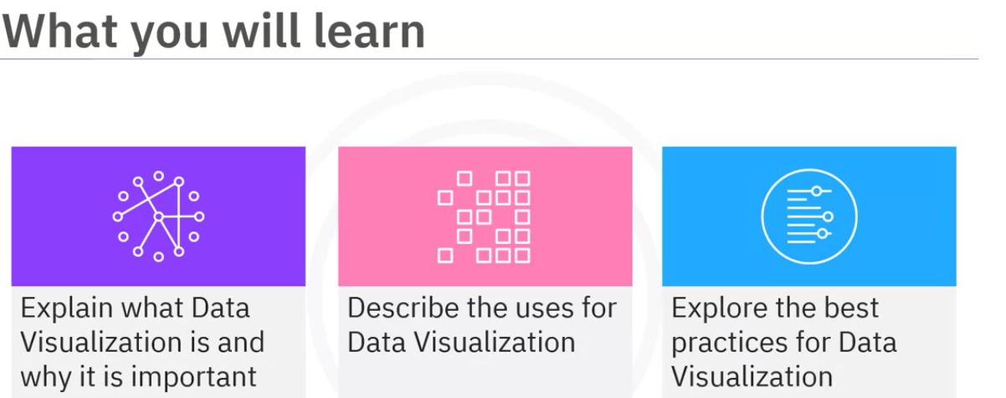

Data Visualization is graphical representation of data and information.

It involvs create many graphs. It can takea variety of forms like creating basic graphs to creating more complex interactive dashboards, maps and infographs.

Basic graphs are used to show simple numerical data. While the interactive graphs are used to show real time information.

Need for Data Visualization

Makes it easy to understand data that might be too complex to comprehend. It can highlight pattens, trends, and relationships in the data that might not be apperent just by looking at the data.

Visualization also enables us to communicate our findings to the stakehoders in a compelling and understandable way. It helps to identify oppurtunities, spot potential problems.

We can gain insights and make informed decisions by examining data over time or across different dimensions.

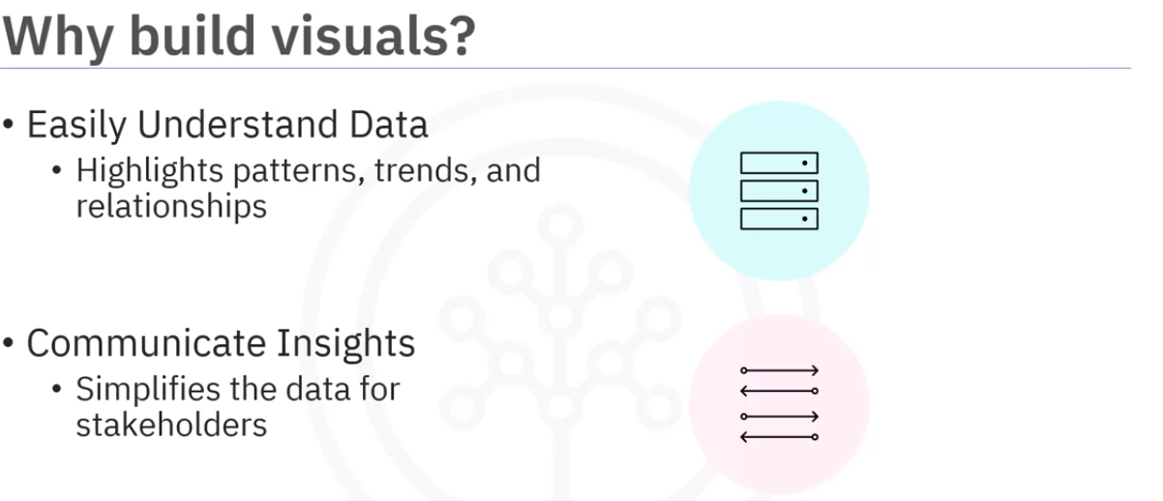

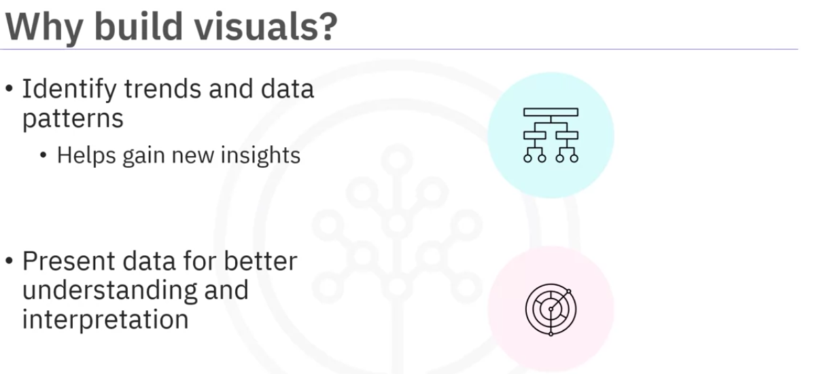

lets see how data visualization can help understand complex data.

The following graphs is from newyork times that shows the impact of COVID-19 in US.

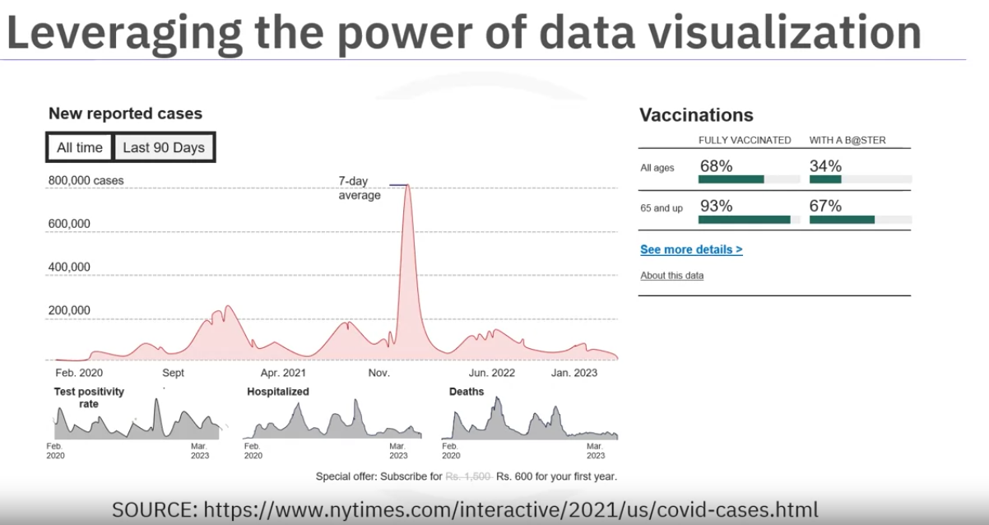

The number of new cases and new deaths are shown using a line graph and the vaccinated data is displayed on the bar graph.

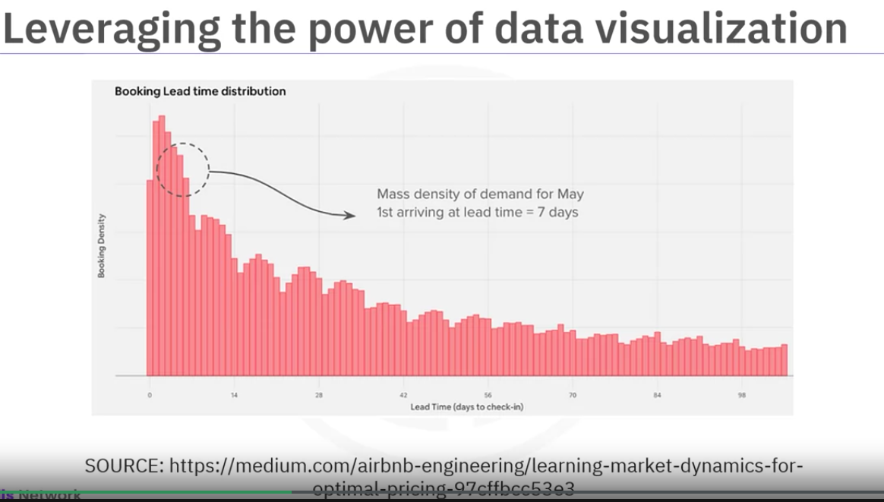

Airbnb uses smart pricing framewormk to assist host and determining the best possible prices for their listings, thereby increasing their profits using a bar graph, the chart displays lead time distribution aggregated to a market level.

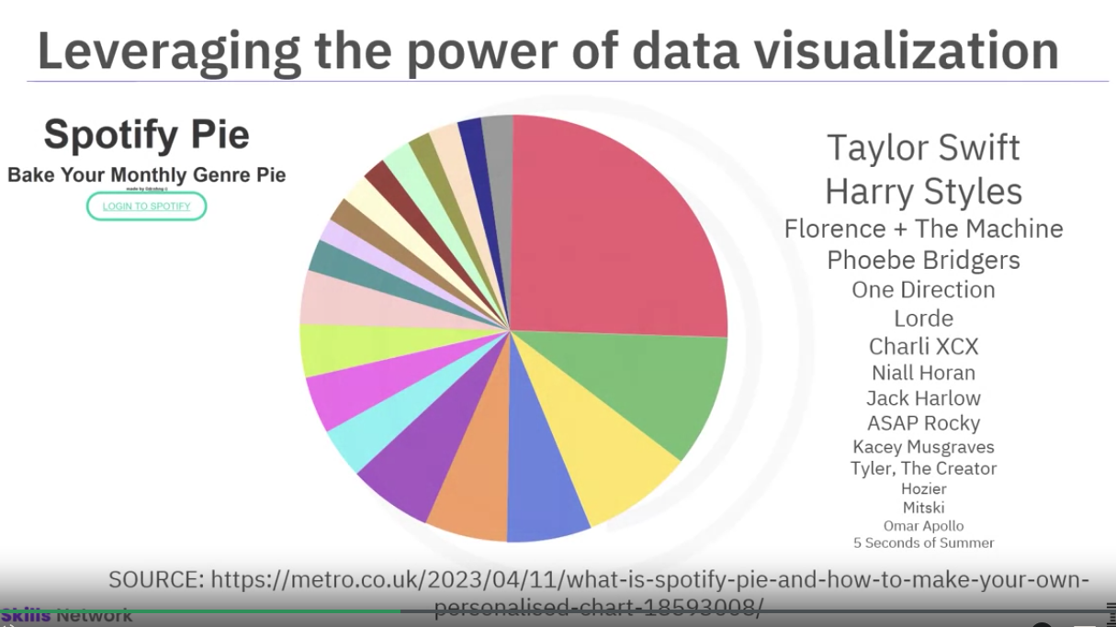

Spotify usesSpotify Pie chart, a unique data visualization to that enables users to create customized pie charts based on their listening habits on spotify.

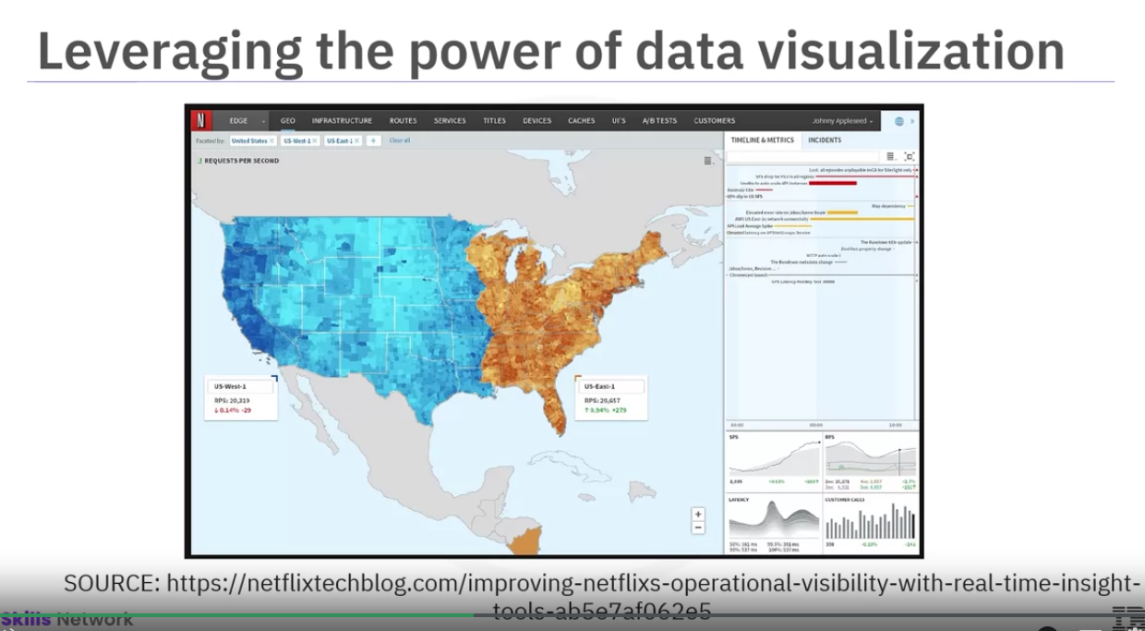

This is a cloropleth map on netflix’s insight tool dashboard with other visualizations like line graphs and bar plots. These dynamic dashboards help them gain a deeper understanding of operations, identify areas for improvement, and quickly address any issues.

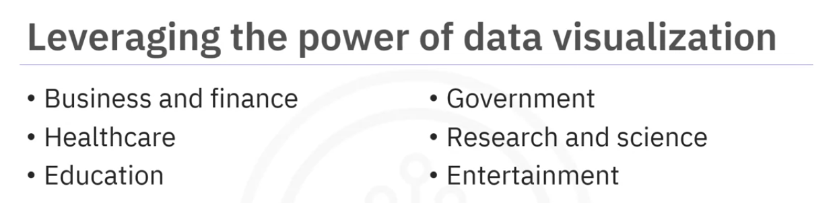

Data visualization is an essential tool for anyone dealing with data. Companies can gain insights into market trends, financial performance, and customer behavior. Healthcare professionals can identify patterns in patient data and develop targeted treatment plants. Visualization helps

analyze student performance and inform instructional decisions leading to better academic outcomes. Visualization helps governments make informed decisions and communicate data to the public. Visualization helps scientists and researchers analyze complex data, develop new insights, and share findings effectively. Visualization helps workers and the entertainment industry determined ratings and ultimately signals to the creators what the audience wants.

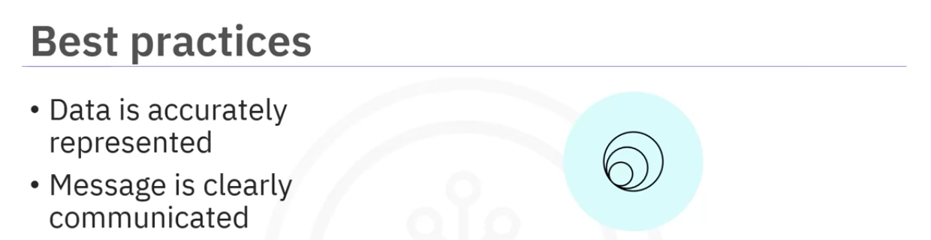

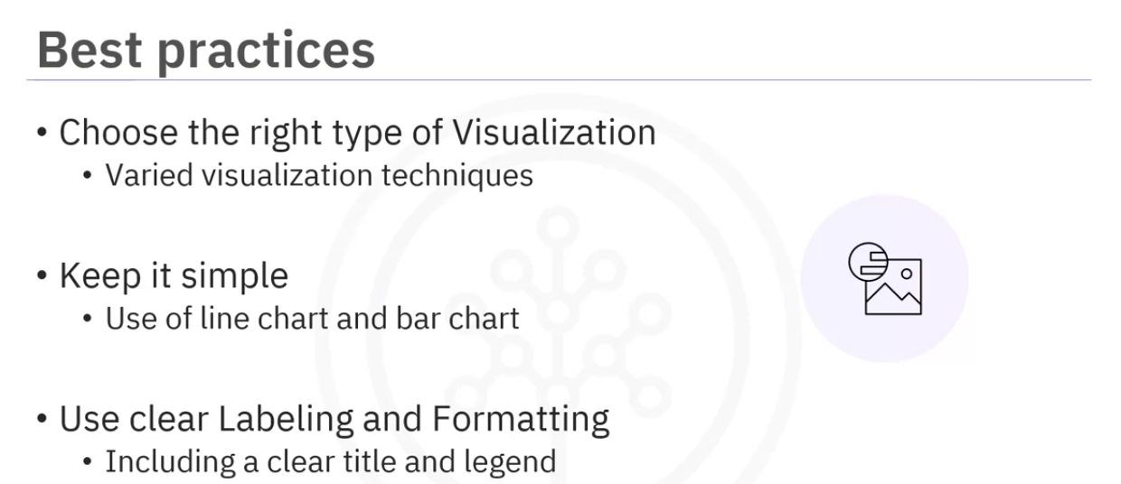

Including unnecessary graphics or information can confuse the audience and distract them from the main message. keep visualization focused on the main point.

Consider who this visualization is for and make the visualization tailored for the audience.

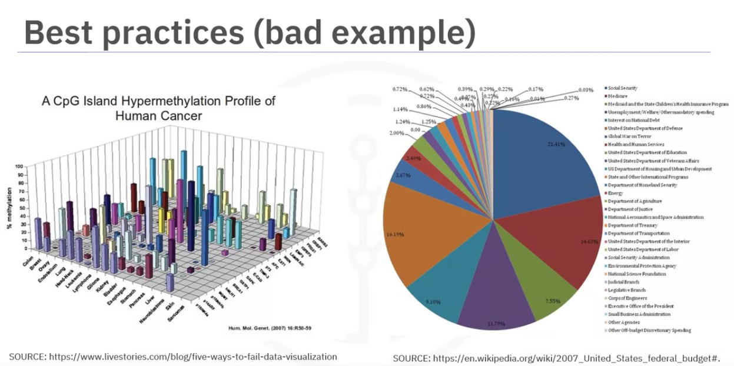

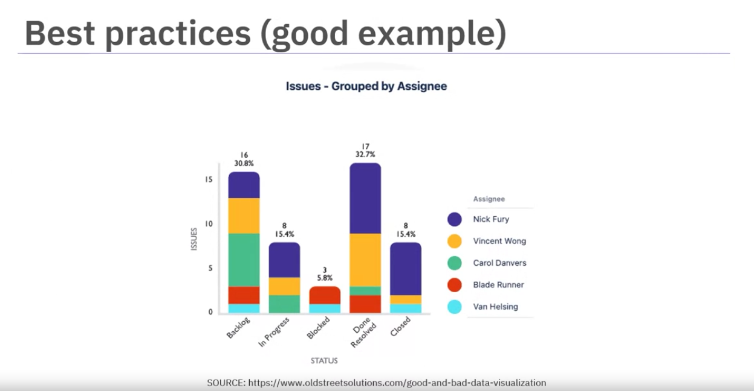

Darkhorse is an anylytics research lab founded at the University of Alberta in 2008.

It specializes inquantitative consulting

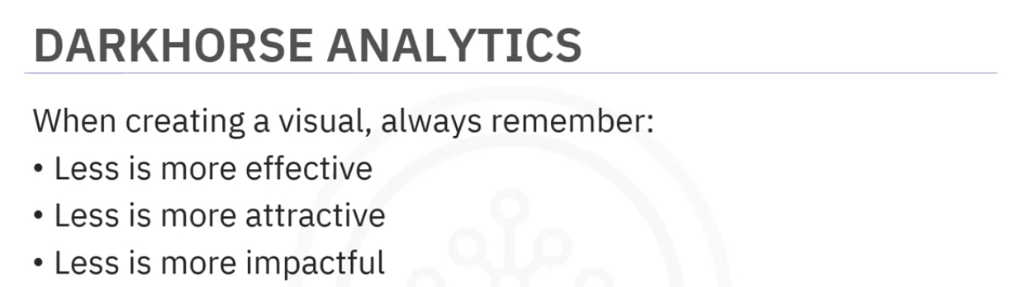

Checkout their website for good and bad plots.

Types of Plots

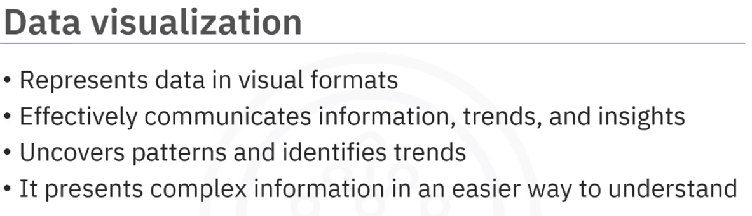

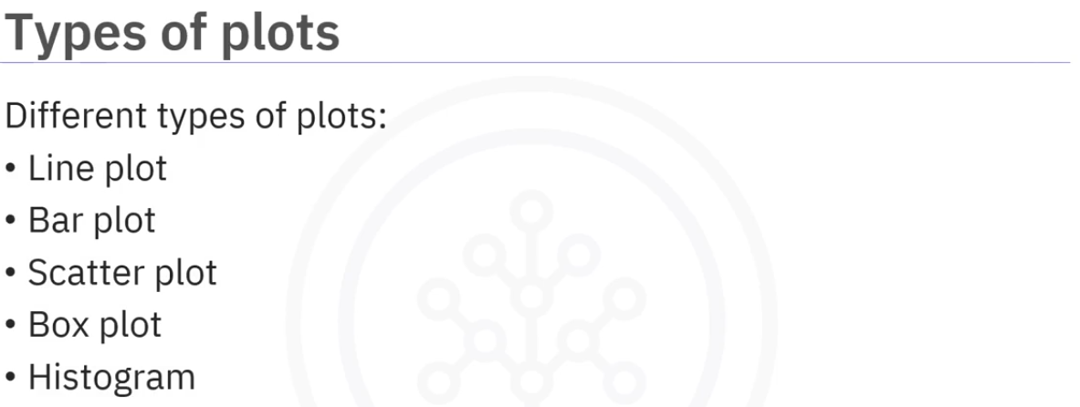

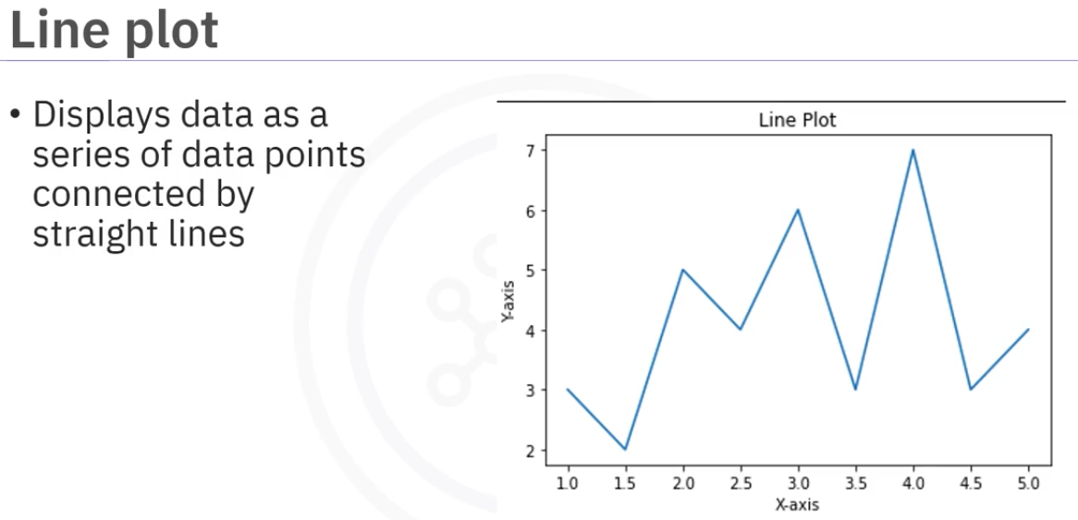

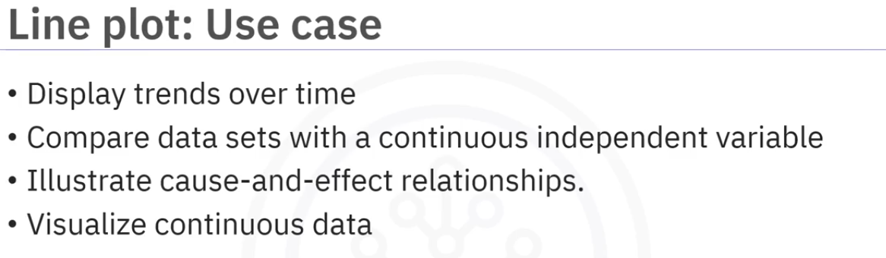

Line plot can be misleading if the scales on the axes arenot carefully chosel to reflext the data accurately.

Example data: stock market fluctuations or temperature over time.

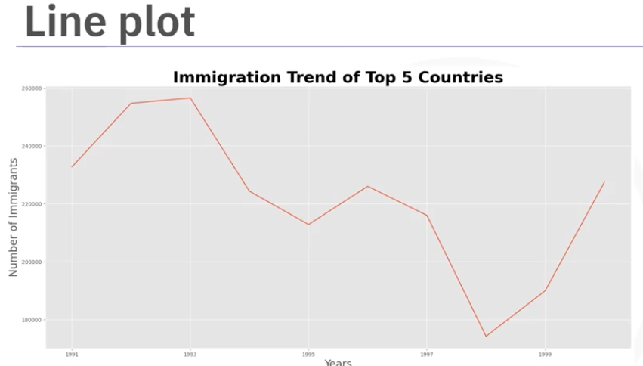

The above lineplot shows a downfall in immigration trends in 1998, however if you will correct the scale on the y-axis to start from zero, the actual trend doesnt seem to be alarming. You can see the actual trend below

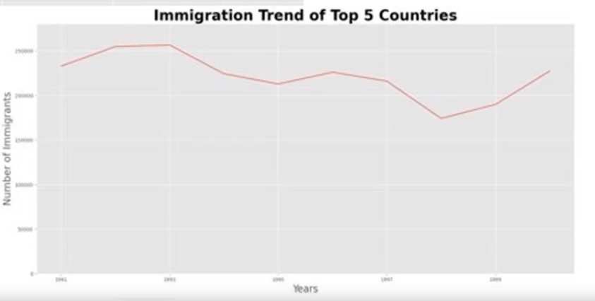

Barplot

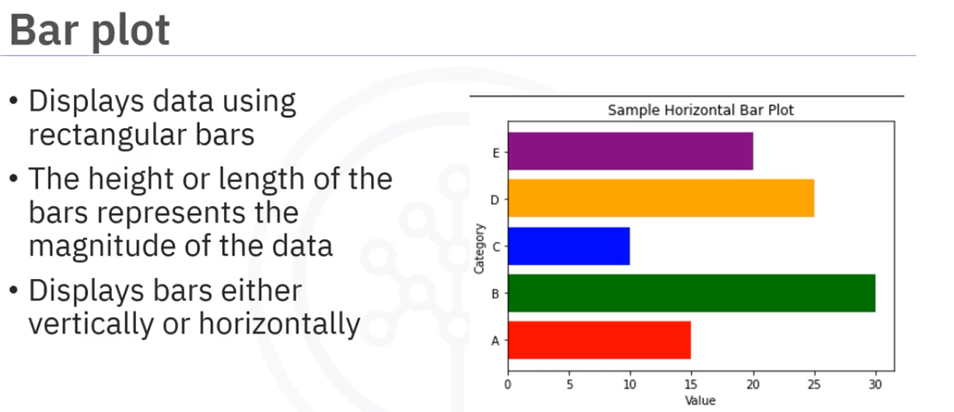

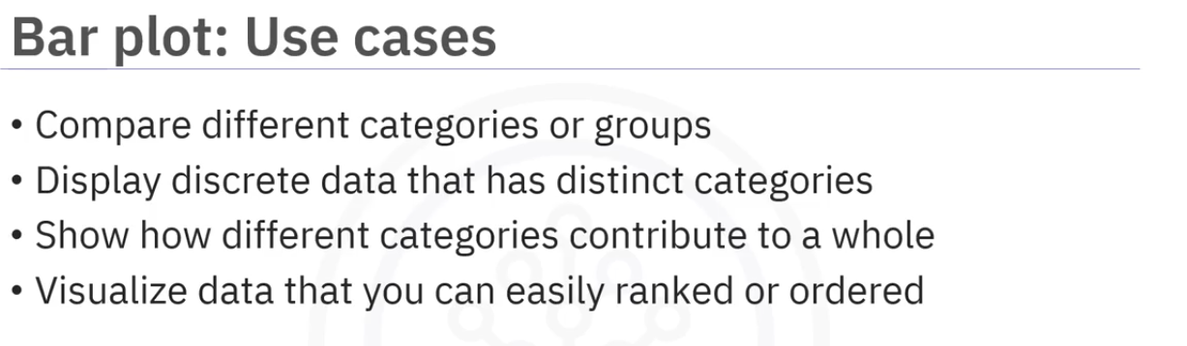

Example data : sales revenue by product, Best selling books

Inaccurate bar choices or axis can show misleading information .The following graph on the left shows there is a lot of difference between 1994 and 1995. But in reality they are closer. This is because the y-axis of the graph on the left starts from 6 while the graph on the right starts from 0.

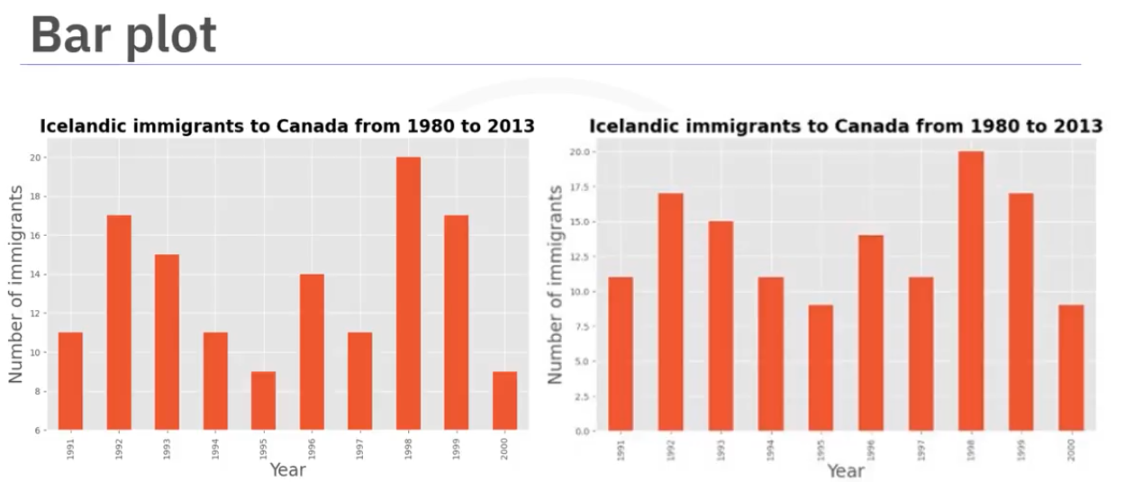

Scatter plot:

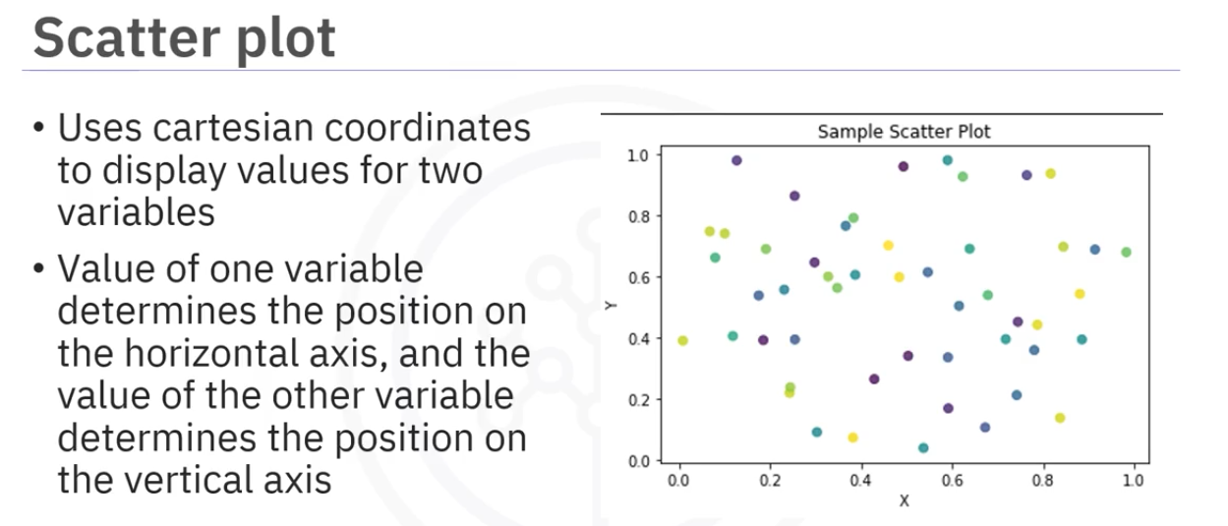

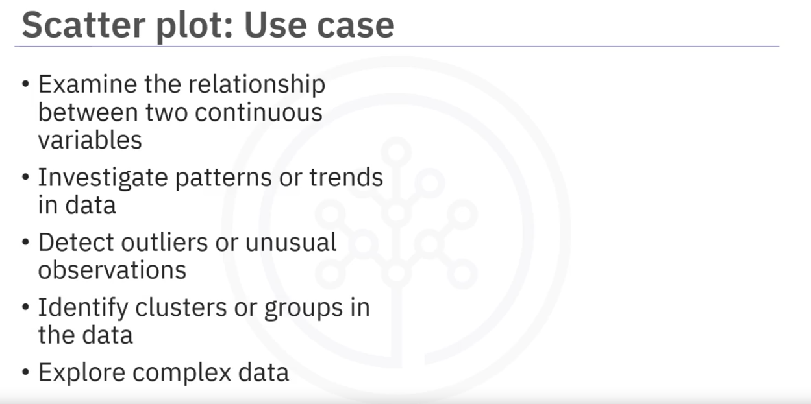

Example data : Temperature vs energy consumption, House prices vs size, finding outliers in test scores or abnotmal stock behaviour.

Outlier significantly impacts interpretation, requiring consideration of their inclusion or exclusion.

In the following plot, the data is plotted with and without outliers, it shows two clusters, but removing outliers makes the data more visible.

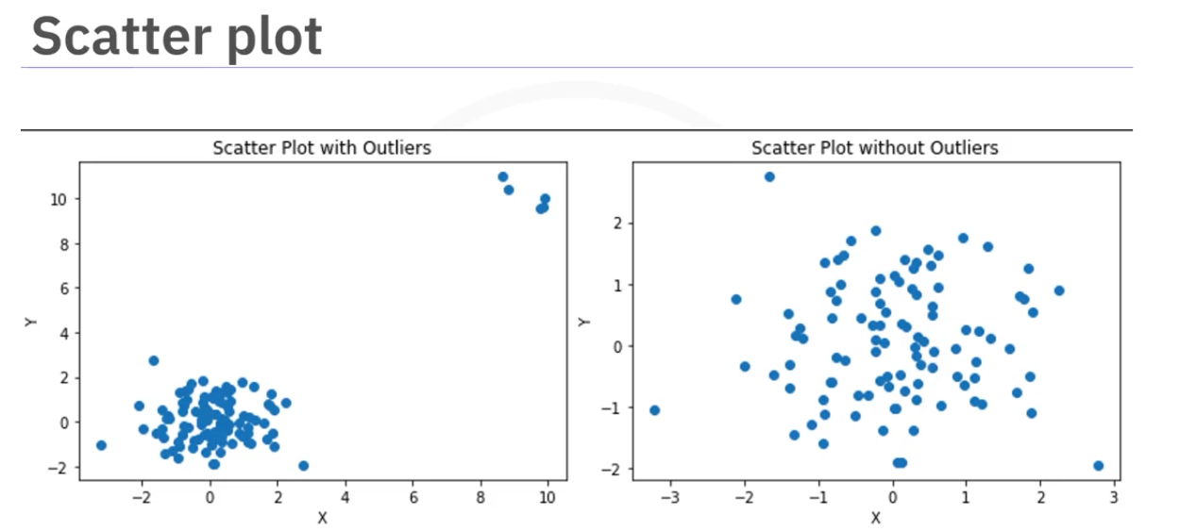

Proper outlier handling, enhances accuracy and meaningful insights in scatter plots.

Box and Wisker Plot:

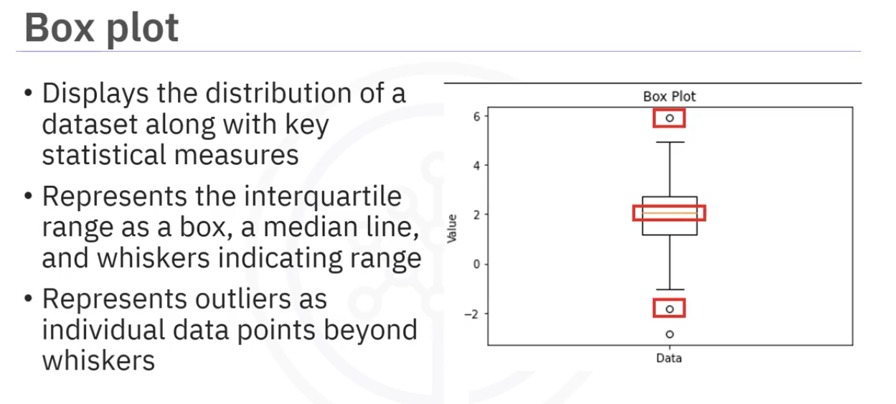

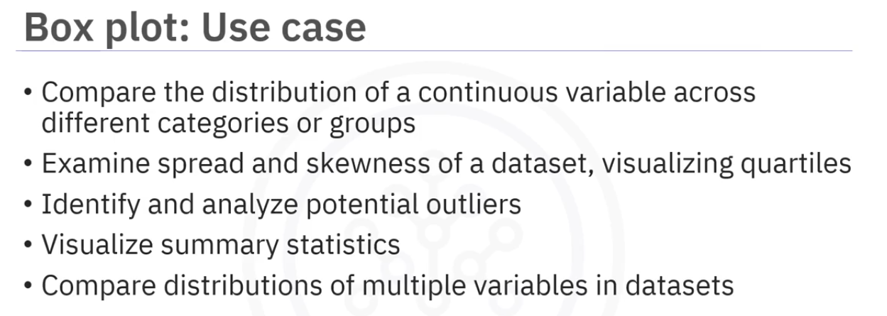

Example Data: employee salaries across different departments.

Box plots hows the number of outliers and the extent of them,

Ignoring or mishandling outliers can distort the interpretation of the data and mask important insights, same as scatter plots.

Histogram:

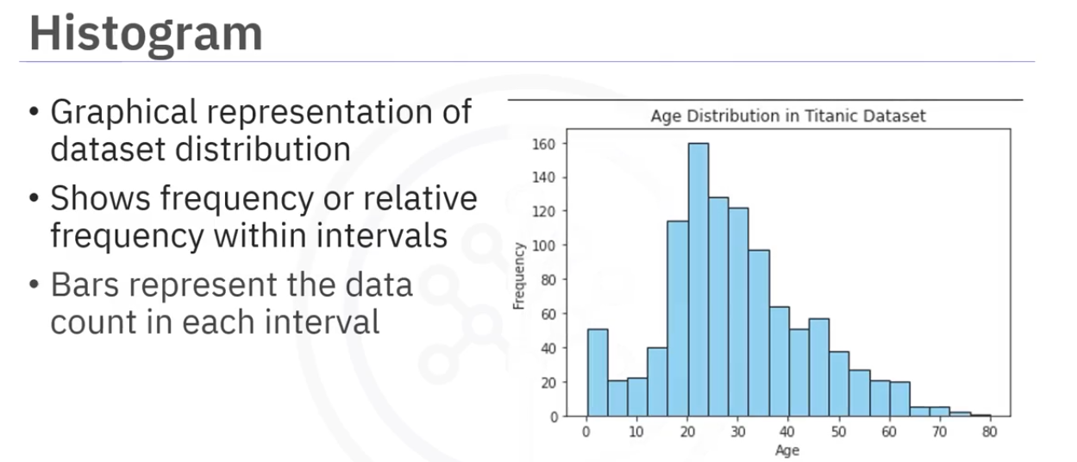

Histograms offer valuable insights like, data distribution, outliers, skewness and variability.

The visuals show if the data is symmetric, skewed or bimodal. We can see the shape and tell about skewness.

Also showscase data variability, allowing to observe concentrations, gaps and cluster that reveal patterns or subgroups.

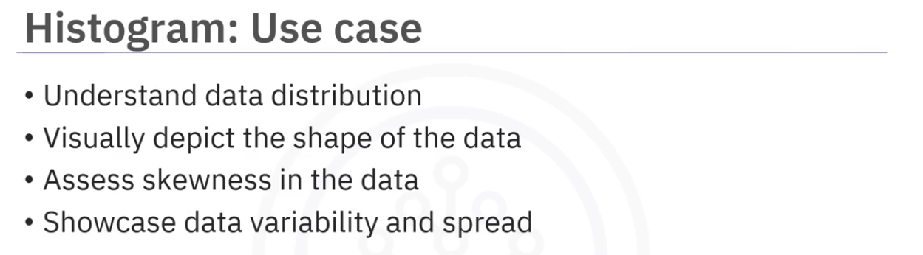

Example data:

Along with issues with scale and inadequate labeling, the binsizes are also a problem. too many bin will make it confusing and too little bins will make the data distribution too simple. The following graph shows all there possible number of bins,

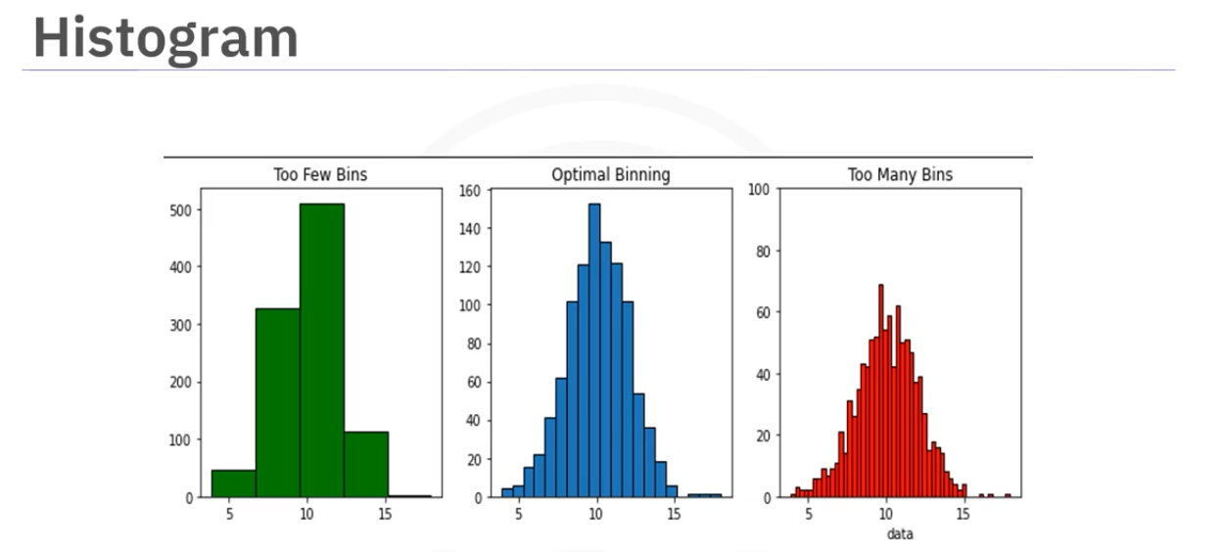

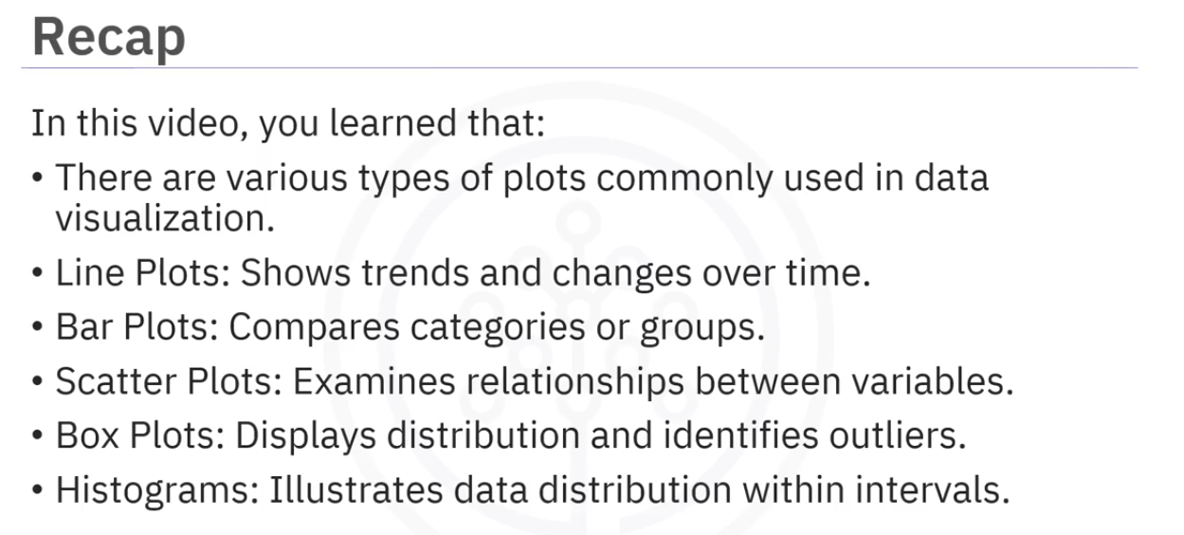

Plotting Libraries

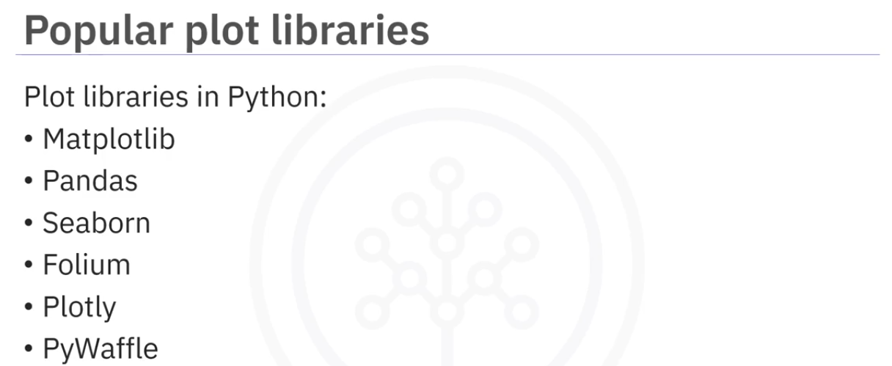

Matplotlib:

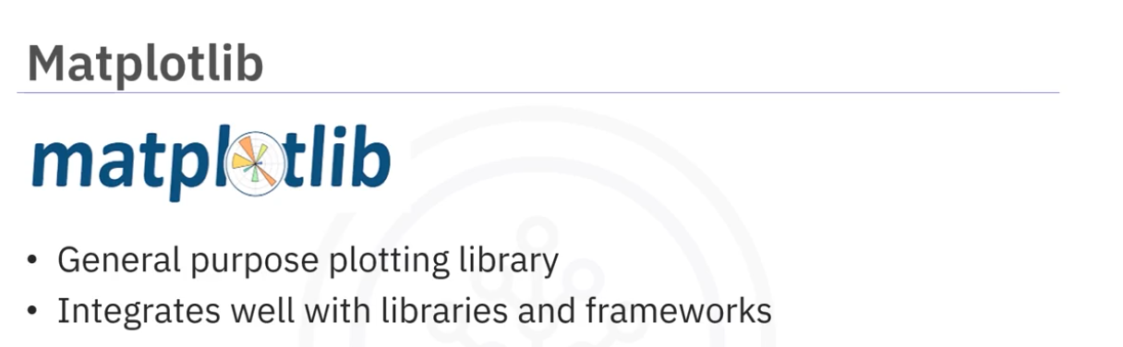

has a vide variety of plots and customization options.

Integrates well with pandas, numpy, seaboarn, plotly. This helps in creating sophesticated and interactive graphs.

Helps creating line plots, scatter plots, bar charts, histograms, pie charts , heatmaps and many more.

Helps customize colors, line styles, marker styles, access labels, titles, legends, and so on.

Integration capabilities makes matplotlib reliable choice for data visualization tasks in python.

Pandas:

Usually used for data manipulation but can also be use for plotting.

Its functions are bult on matplotlib. Makes it easy to apply graphs.

Features:

Easy to create line plots, scatter plots, bar charts, histograms, pie charts directly from dataframes.

Used for exploratory data analysis.

Seaborn:

Bulit on top of matplotlib.

Great option for specialized statistical visualizations,

Provides stylish and specialized plot types such as caategorical plots, count plot, heatmaps, violin plots, scatter plots, bar plots, and manymore.

Features:

Comes with a various color palettes and styles that enhanses the aesthetics of the plot.

Offers functions to combines multiple plots in a grid layout. which can be useful for comparing multiple variables or subgroups.

Its integration with pandas allows us to use pandas dataframe and series directly to plot graphs.

The combination of statistical visualizations, integration with pandas and ease of use, good aesthetics and builtin themes makes it a polular option for data analysts.

Folium

Excellent option for geospatial data visualization.

Helps to build interactive and customizable maps whether its choropleth , point maps or heatmaps.

Features:

Integrates well with pandas and numpy.

Popular choice for geospacial data vis and analysis.

Plotly:

Has Highly interactive plots and dashboards.

Can create a variety of plots like line plots, barplots, pie charts, 3d plots, chropleth maps and many more.

Feather:

Its plotly dash feature enables to create dashboards with rich visualizations and controls.

Since plotly is web based, it enables the rendering and, ciewing of plots in web browsers.

This makes it convenient for sharing visualizations online, embedding them in web applications or dashboards, and collaborating with others.

Pywaffle:

Visualizes categorical data using waffle charts in an simple but effective way.

With PyWaffle, you can create waffle charts , square pie charts, donut charts, and many more.

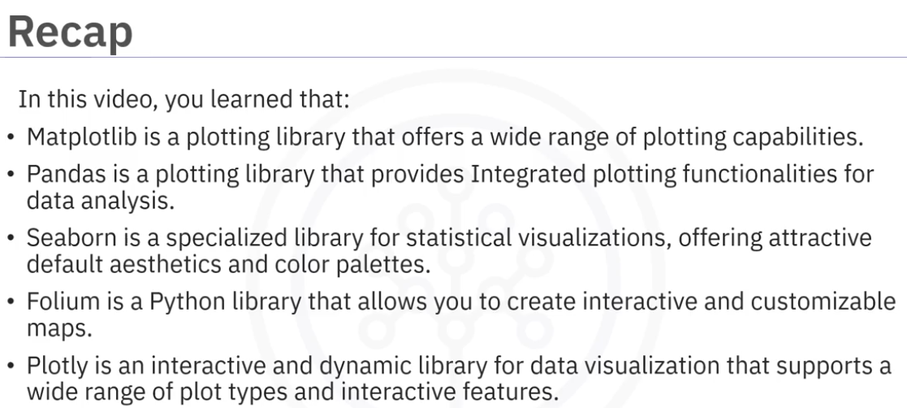

Intro to Matplotlib

Most widely used vis library in python

Made by John Hunter - neurobiologist.

Based on matlab

initially developed for EEG/ECog Visualization tool

Had a scripting interface for quick and easy generation of plots.

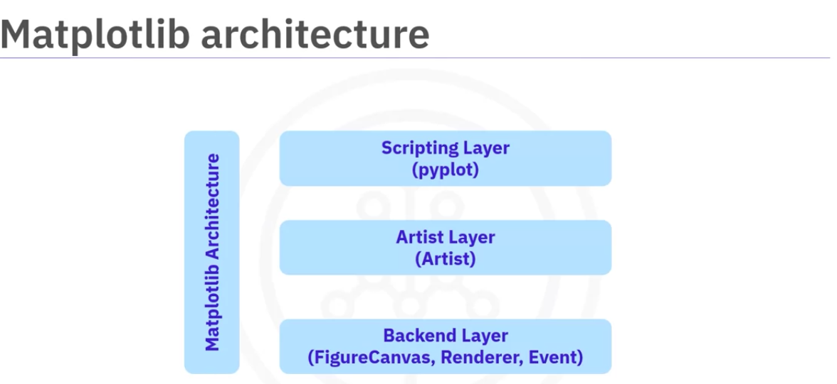

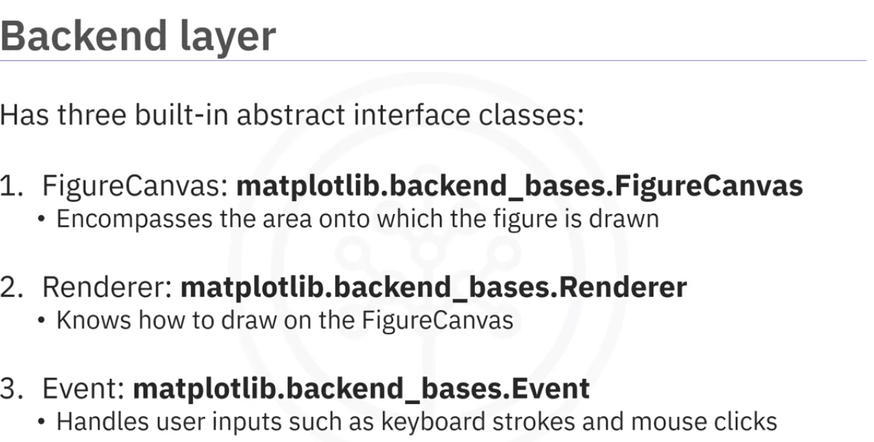

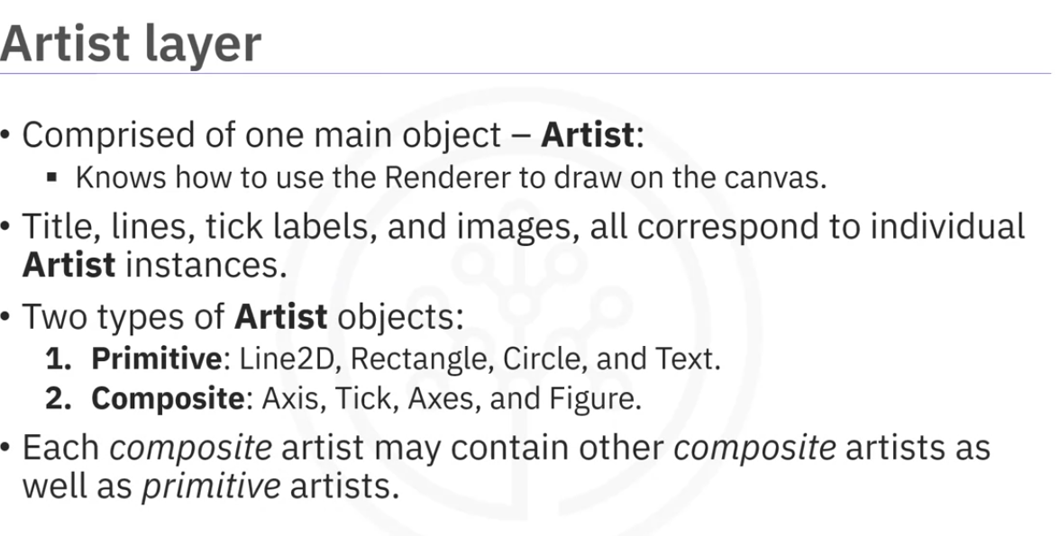

The article layer is syntax heavy. programmers wotk with the arthist larer and the backend layer as they offer greater convenience while integrating matplotlib with web application servers.

For everyday data scientist tasks like visualizations the scripting interface pyplot is better.

pyplot automatically defines a canvas and creates a Figure artist object and connect them together. This makes it easy for us to concentrate in the important details.

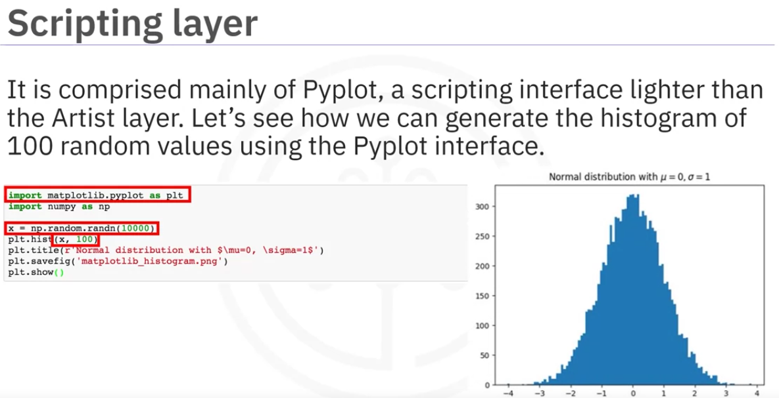

Anatomy of figure

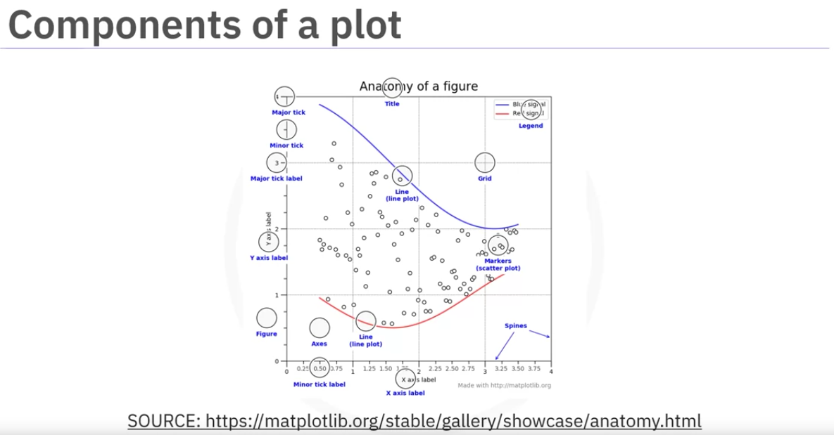

1 Needs two axis to make two plots on one figure.

The axis provides scales and tick marks for plotting data.

The actual data is plotted as points or markers in the plot.

A title should be there

labels describe data being plotted.

including legend at will display those labels.

add a grid to helpvisually aligned data points to and aid in reading values from the plot.

annotations to provide supplemental information or explainations about specific data points or regions in the plots

We can have differnet shapes(also called symbols) for the individual data points,colors, and styles,

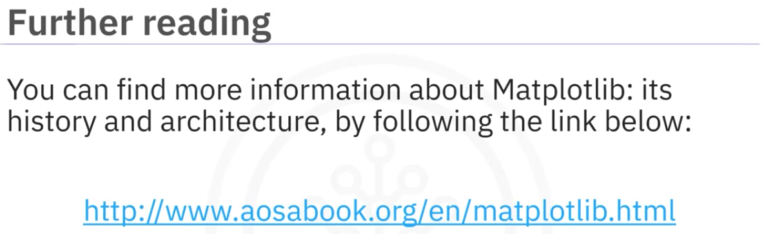

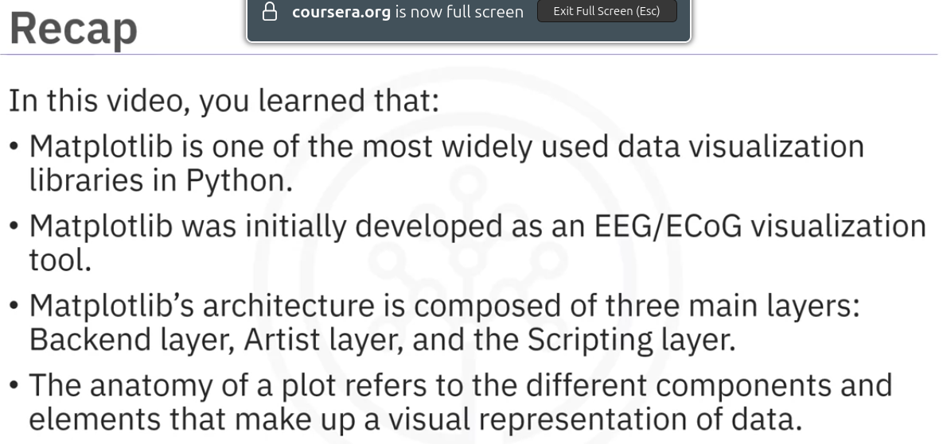

Basic Plotting using Matplotlib

Matplotlib is a well established datavisualization library that can be integrated in different environments suchas Python scripts, python and ipython shells, Juyter notebook, web application servers and in Graphical user interface toolkits

Jupyter notebook has specialized support for matplotlib so we simply need to import it and we can use it from then.

Plot method:

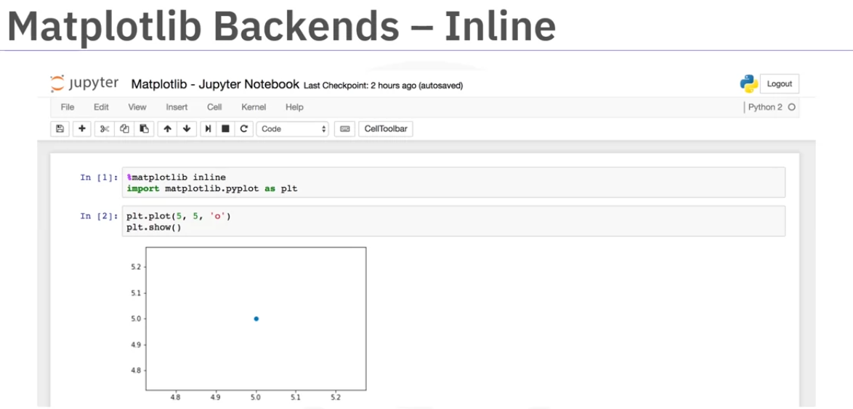

%matplotlib inline is a magic function that can generate plots into the browser.

matplotlib has multiple backends available and inline is one of them.

One limitation of using inline is that the plots cannot be modified once its rendered.

So we cannogt add the labels once the plot renders.

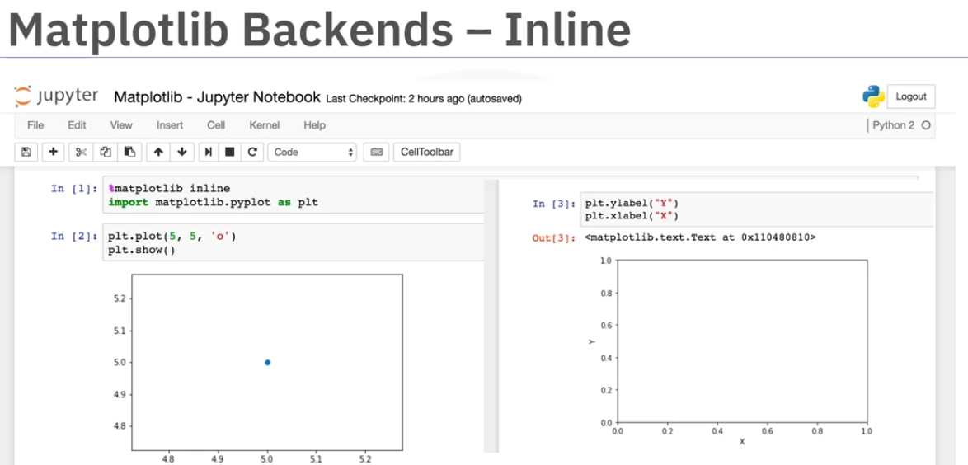

we need to generate a new plot with the title,axis lables when we are plotting

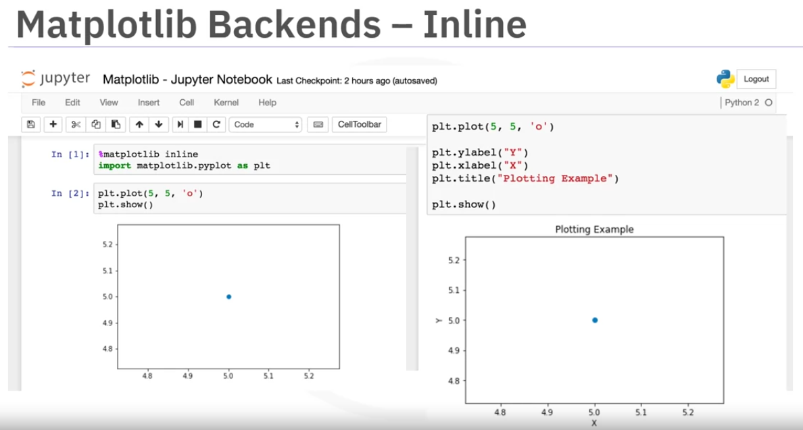

There is a backend called ‘notebook’ which allows us to add something to the existing figure.

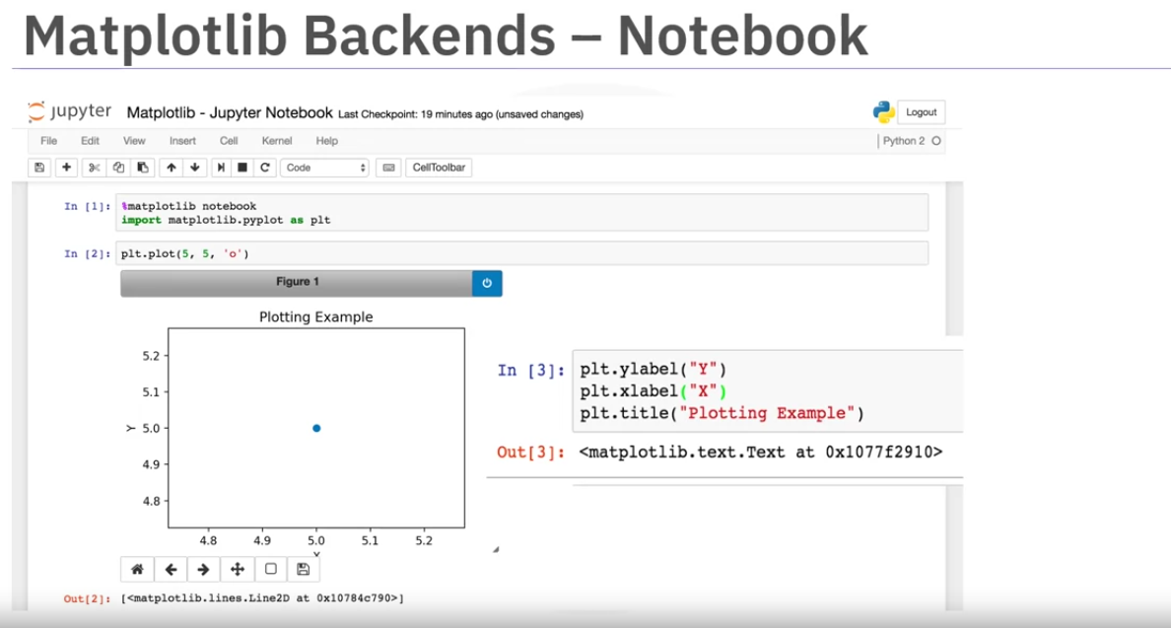

Pandas has matplotlib integration. We can use the series or dataframes to directly plot graphs.

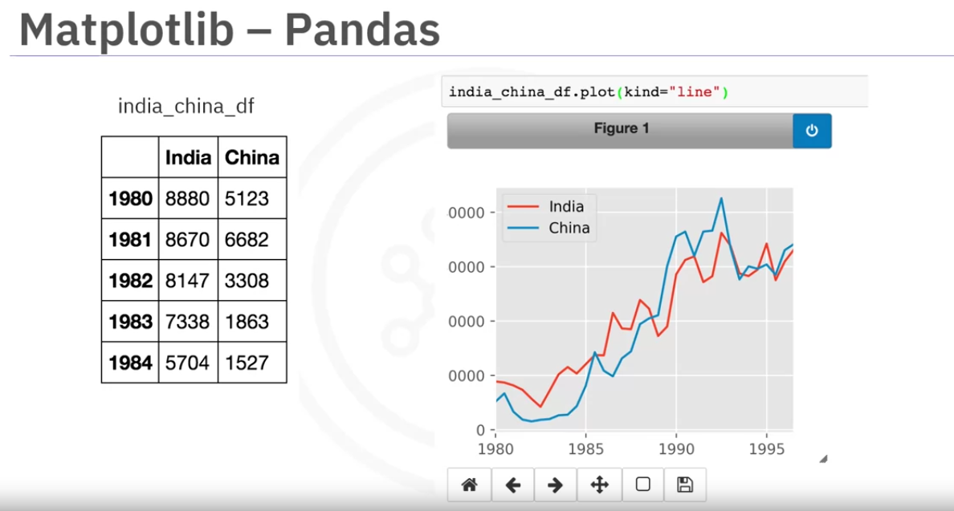

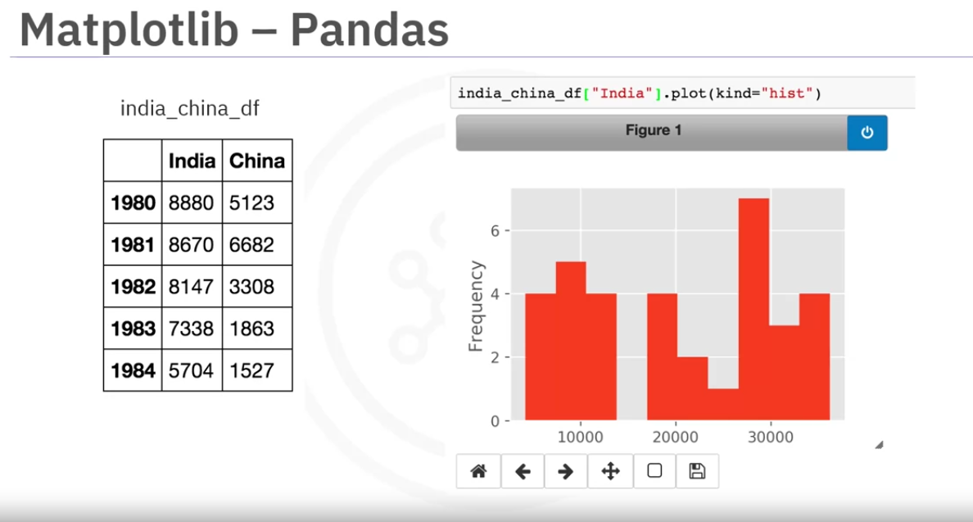

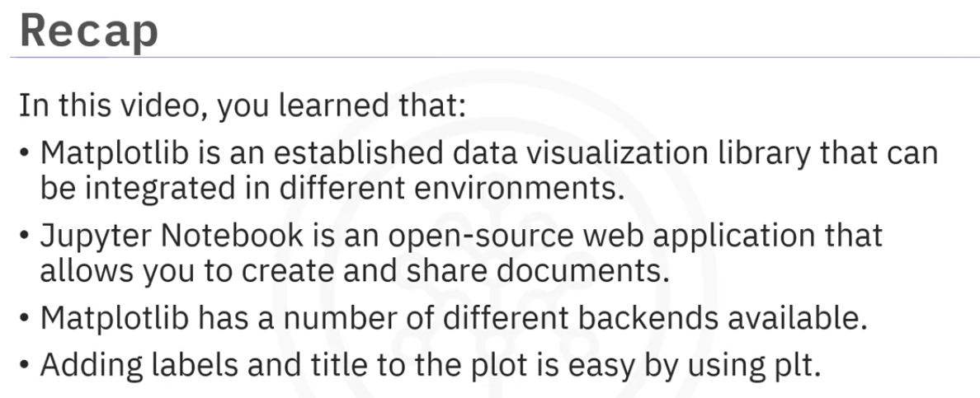

Dataset on Immigration to Canada

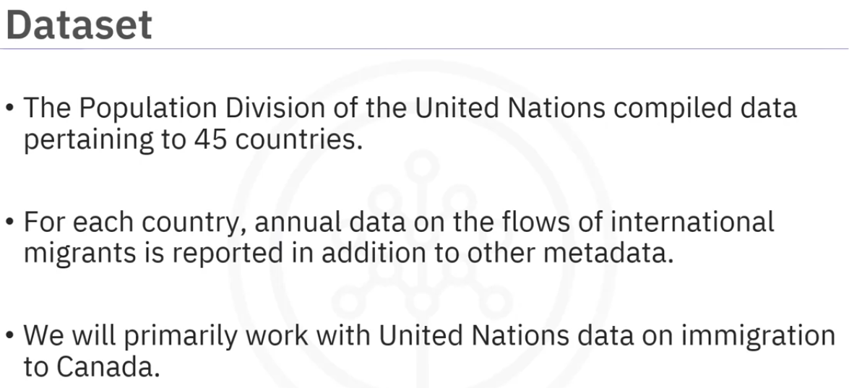

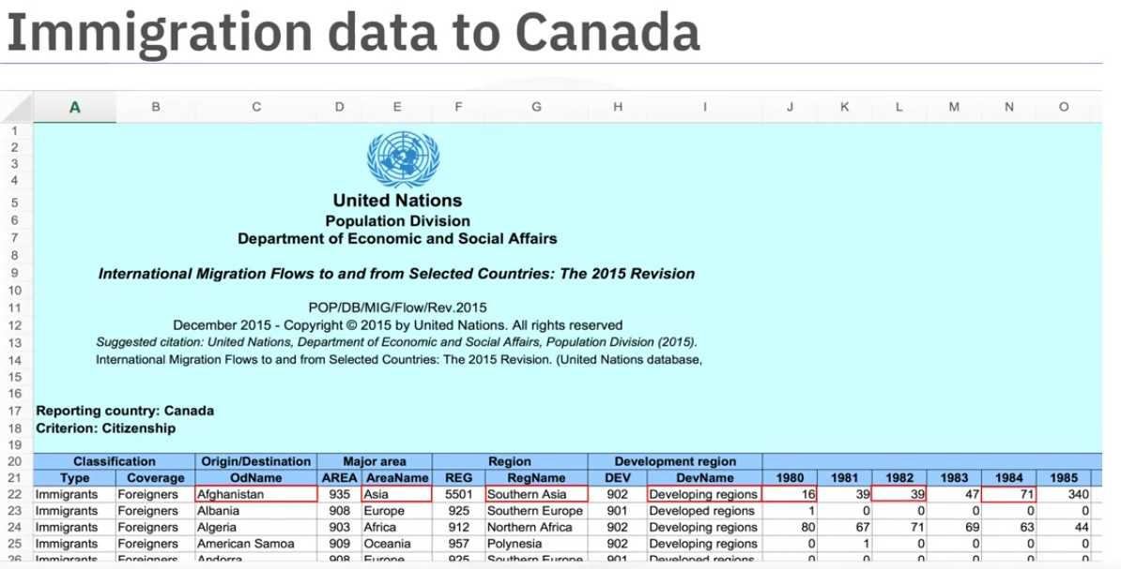

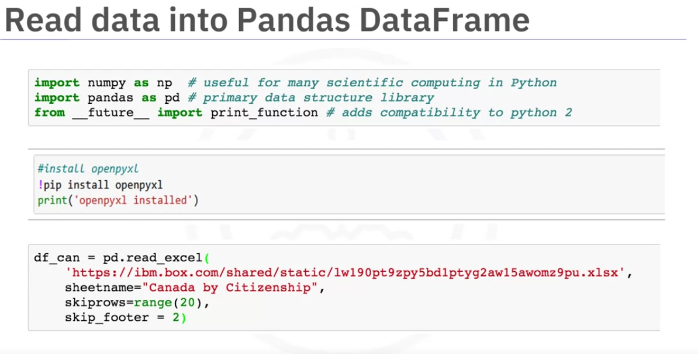

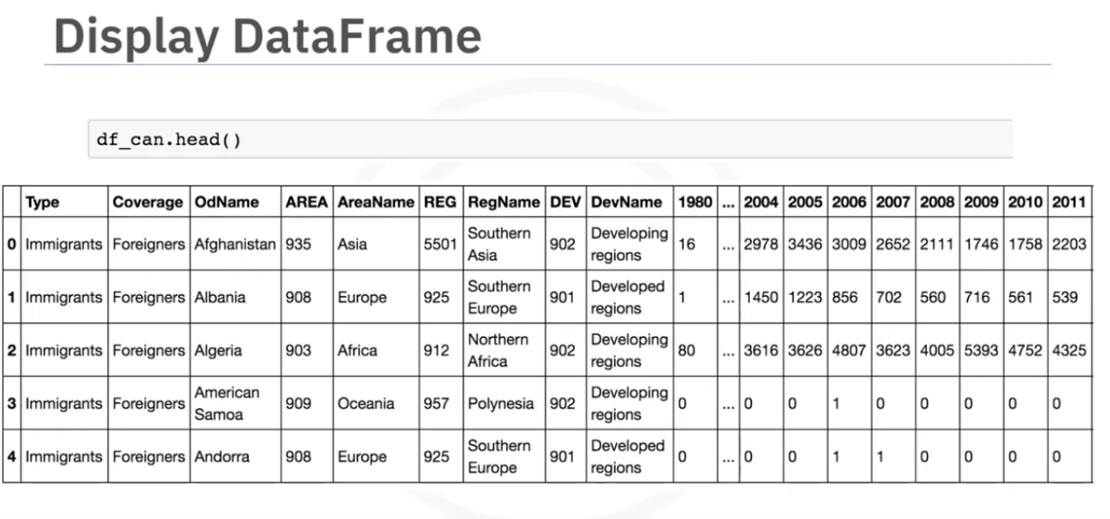

After processing the data in a required way to make it easy to understand the data will look as follows.

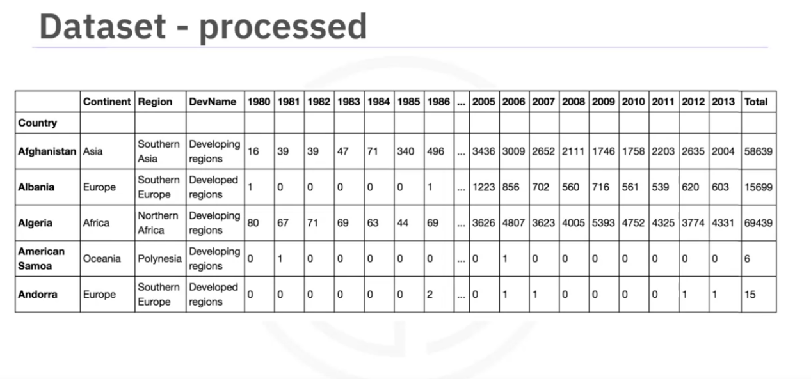

Line Plot

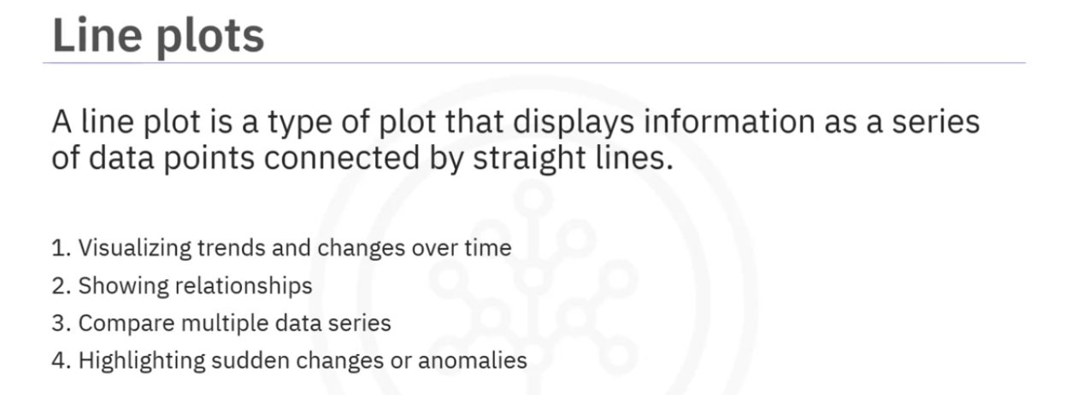

Examples:

popular for time series data. changed in stock prices over time, website traffic or temperatur fluctuations

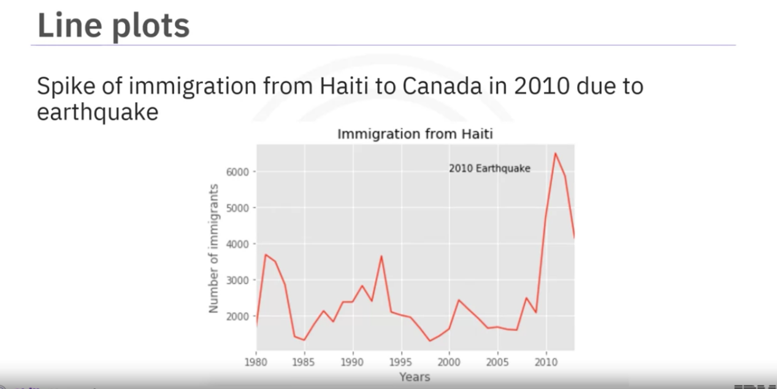

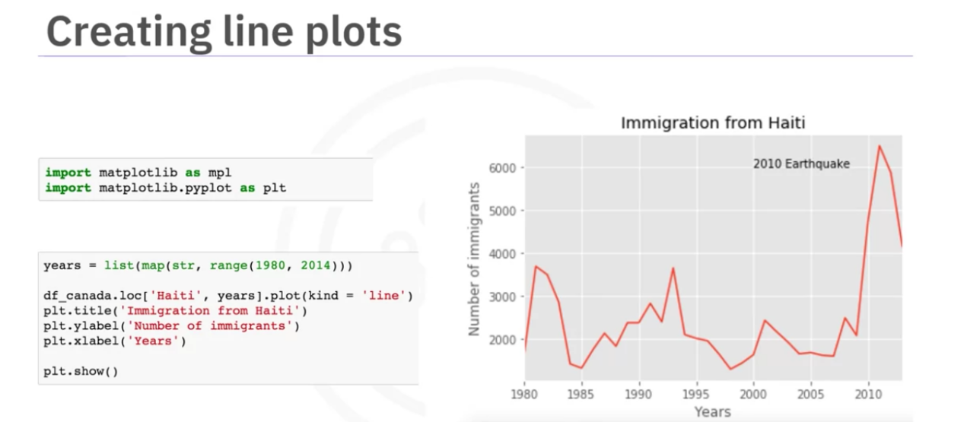

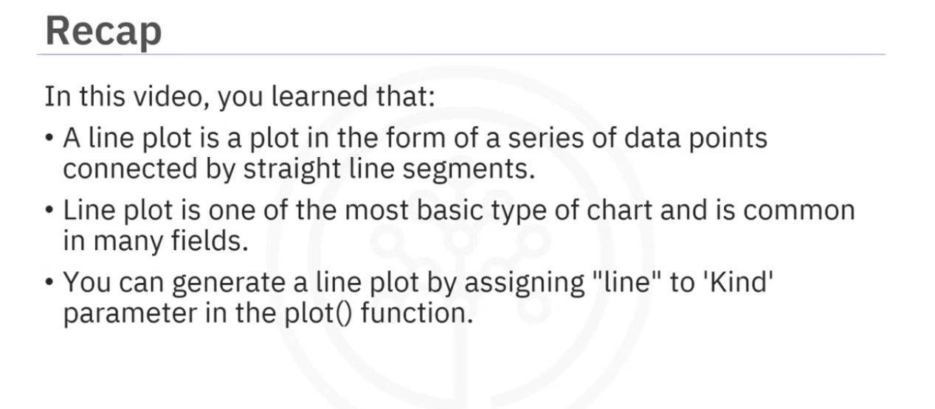

Week1 Lab 1 here

Week1 lab 2 here

# Summary: Introduction to Data Visualization Tools

Congratulations! You have completed this module. At this point in the course, you know:

Data visualization is the process of presenting data in a visual format, such as charts, graphs, and maps, to help people understand and analyze data easily.

Data visualization has diverse use cases, such as in business, science, healthcare, and finance.

It is important to follow best practices, such as selecting appropriate visualizations for the data being presented, choosing colors and fonts that are easy to read and interpret, and minimizing clutter.

There are various types of plots commonly used in data visualization.

Line plots capture trends and changes over time, allowing us to see patterns and fluctuations.

Bar plots compare categories or groups, providing a visual comparison of their values.

Scatter plots explore relationships between variables, helping us identify correlations or trends.

Box plots display the distribution of data, showcasing the median, quartiles, and outliers.

Histograms illustrate the distribution of data within specific intervals, allowing us to understand its shape and concentration.

Matplotlib is a plotting library that offers a wide range of plotting capabilities.

Pandas is a plotting library that provides Integrated plotting functionalities for data analysis.

Seaborn is a specialized library for statistical visualizations, offering attractive default aesthetics and color palettes.

Folium is a Python library that allows you to create interactive and customizable maps.

Plotly is an interactive and dynamic library for data visualization that supports a wide range of plot types and interactive features.

PyWaffle enables you to visualize proportional representation using squares or rectangles.

Matplotlib is one of the most widely used data visualization libraries in Python.

Matplotlib was initially developed as an EEG/ECoG visualization tool.

Matplotlib’s architecture is composed of three main layers: Backend layer, Artist layer, and the Scripting layer.

The anatomy of a plot refers to the different components and elements that make up a visual representation of data.

· Matplotlib is a well-established data visualization library that can be integrated in different environments.

· · Jupyter Notebook is an open-source web application that allows you to create and share documents.

· · Matplotlib has a number of different backends available.

· · You can easily include the label and title to your plot with plt.

· · In order to start creating different types of plots of the data, you will need to import the data into a Pandas DataFrame.

· · A line plot is a plot in the form of a series of data points connected by straight line segments.

· · Line plot is one of the most basic type of chart and is common in many fields.

· · You can generate a line plot by assigning "line" to 'Kind' parameter in the plot() function.

·